Staying Healthy & Connected During the Coronavirus Pandemic To My Dear Patients, During this unprecedented and stressful time, I wanted to offer some suggestions and resources for you and your loved ones. This will be a difficult and painful part of all of our histories. But I trust that unexpected gifts, growth and wisdom will also come from it. In the meantime, there are things we can do to take care of ourselves and one another. Here are some thoughts and ideas… 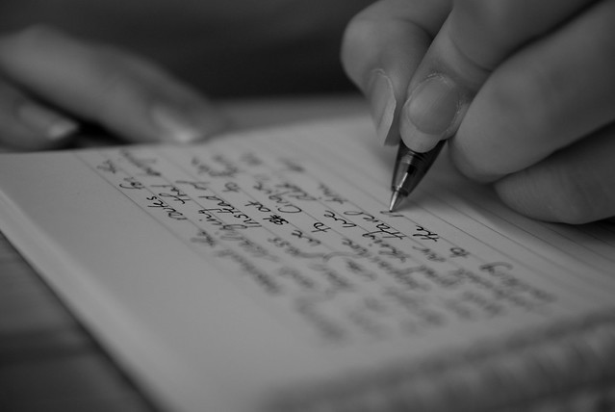 This Photo by Unknown Author is licensed under CC BY-SA-NC  - Create a gratitude journal. - While it is always important to “feel our feelings” (cry if you need to!) at times like these it can be especially helpful to intentionally focus on experiences for which are grateful. Use a journal to write down at least 3 things you feel grateful for at the end of the day (or throughout) and why they happened. This will help you to pay attention to small but healing and human moments that keep you going. This Photo by Unknown Author is licensed under CC BY-SA-NC | This Photo by Unknown Author is licensed under CC BY-SA-NC
*Try to keep some routines. Those routines may be different than the usual, but things such as getting up and going to bed at regular times, meals, getting outside for exercise, are important to maintaining as much of a sense of normalcy as possible. Keep routines and structure within your family system as well.
*Limit your exposure to the news. Stay plugged in as long as it helps undo aloneness, but be mindful of when you may be feeling compelled or too stressed out and turn it off or shut it down. It will be there for you when you need it again.
*Make time to be in touch with loved ones and friends via phone, video chat, text or email or in person if they live with you. It can keep you feeling connected to what and who matters most. Be spontaneous but also schedule it in as it helps structure your day and gives you something to look forward to.

Ideas for staying mentally & emotionally healthy

Laugh
Watch your favorite comedian, funny movies, play games, let yourself be silly and laugh at yourself. Positive emotions help buffer us against pain, keep perspective, and keep us healthier.

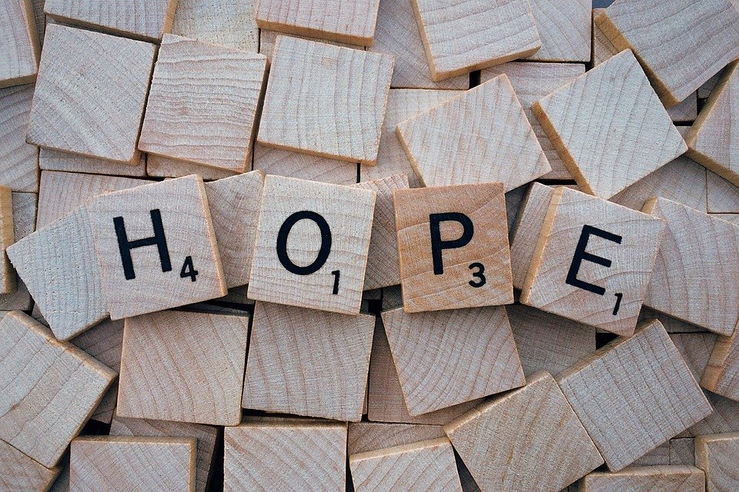

Practice Hope
Watch movies, read books or stories about hope triumphing over darkness. Read speeches or watch videos of inspiring people who have survived and learn from them what helped when they were feeling overwhelmed, frightened or lost.

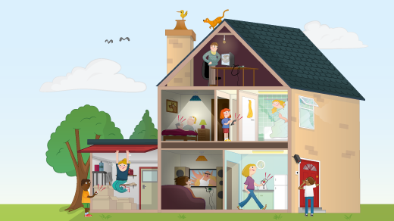

Do a home project…
You have been putting off for a while. Organize closets, basements, drawers. Purge stuff you no longer need. Paint a room. You are spending more time there now anyway. You might as well make it as pleasing as possible.
Develop or start a hobby. Paint, knit, work on those coloring books, take pictures, make albums, read new or beloved old books, cook, play music, learn to refurbish furniture. Anything that absorbs you and nourishes you at the same time.
coo

Get Healthy
As tempting as it may be to indulge in habits or substances, your body/ mind does not need the added stress of crashing, withdrawal or hangover. Give yourself a break and do things that make you feel good in the short and long run, like:
- Breathe
- Eat healthfully
- Take vitamins
- Avoid things you know make you feel blah
- Get fresh air and sunshine daily
- Stay hydrated and exercise
Get Spiritual
Reach into or cultivate places of deep meaning and higher purpose in yourself and your life. Why are you here? What do you want your life to be about? Where do you feel called? What is most important to you? What unites you to all people and the earth? What makes you uniquely you? Meditate, pray, take time to be silent and listen.

Smile and Practice Kindness
We cannot shake hands but we can make eye contact, smile and be gracious. We can practice communicating our humanity and noticing the humanity of everyone around us.
And act on your impulses to reach out, to help, to offer support, to check in. You will not regret it.

Slow Down & Don’t Judge
Take this as an opportunity to learn to be easier and more gentle with yourself. Slow down because the whole world is slowing down and you will not lose any races right now. Our individual and collective health depend on our being present, mindful and aware. Take your time.
And avoid judgment as much as possible, including of yourself. We are all novices at pandemics. None of us will do this “right.”

Get Physical!
Try to get some kind of physical activity in at least once a day. Walking, jogging, bike riding, yoga. There are instructional videos on all kinds of exercise on-line. The weather is cooperating and even I cannot now complain I don’t have “time.”
